WET & WILD
FIELD DAY STATIONS
1 Adrenaline Challenge
2 Break: Hydration Station
3 Pose & Print
4 Elimination: Roller Cage Ball
5 Lava Monster: Floor is Lava
6 Dance Battle
7 Rockin’ Roller Racer Relay
8 Field Goal Challenge
9 Hoppin’ Hurdles Relay
10 Splash Waterfall Water Slide
11 Popsicle Break
12 Parrot Bay: Paddle Cup Relay
13 Catching some waves: Water Balloon Toss
14 Water you doing?: Leaky Cups Relay
15 Surfin Slide: Inflatable Slip and Slide
16 Sponged Relay
17 Making a splash: Tug of War
18 Crystal Cliff: Slip and Slide Target Challenge

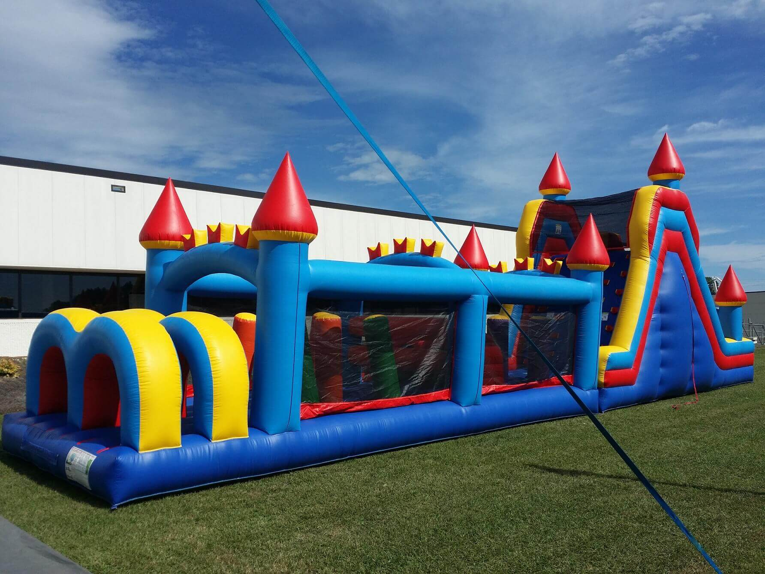
Adrenaline Challenge

Students race against another class through the obstacle course. First class finished wins the point.

- Students take their shoes off and place them on the tarp.
- Classes must be evened out prior to beginning (decide if students must go twice).
Hydration Station
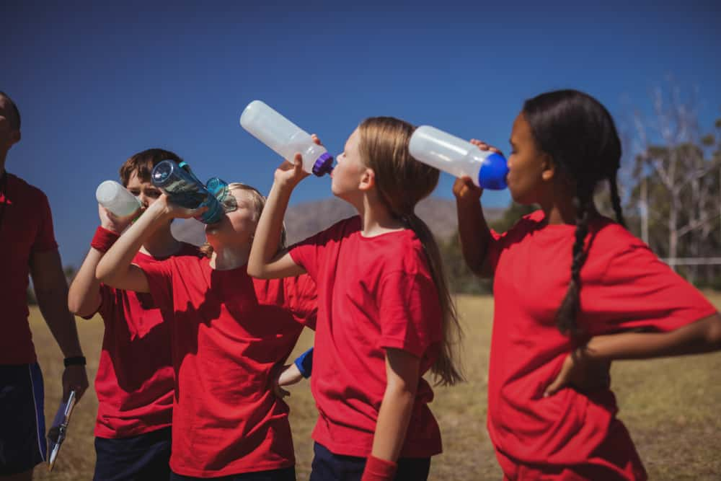
Students rest and refuel with provided water.

- Students only receive 1 bottle of water
- *This is a good time to have a class snack or use the restroom
Pose & Print
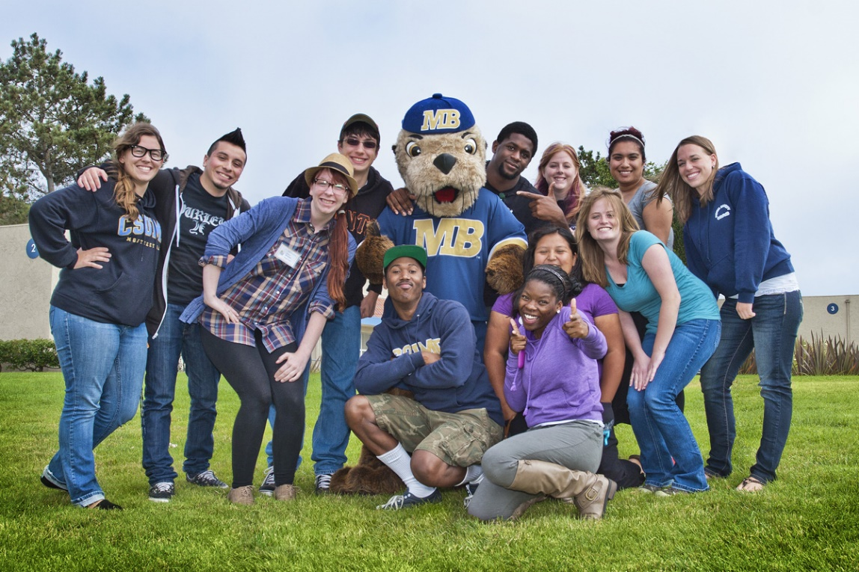
Students get in position for a class photo that will be printed out and delivered at a later date.

Elimination:
Roller Cage Ball
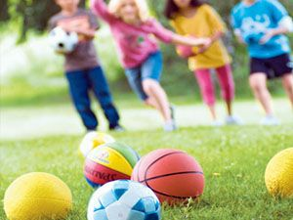
Students compete to be the last man standing for their class by dodging the rolling foam balls.

- Eliminated students go to their class’s cage and roll students out from behind

Lava Monster:
The Floor is Lava
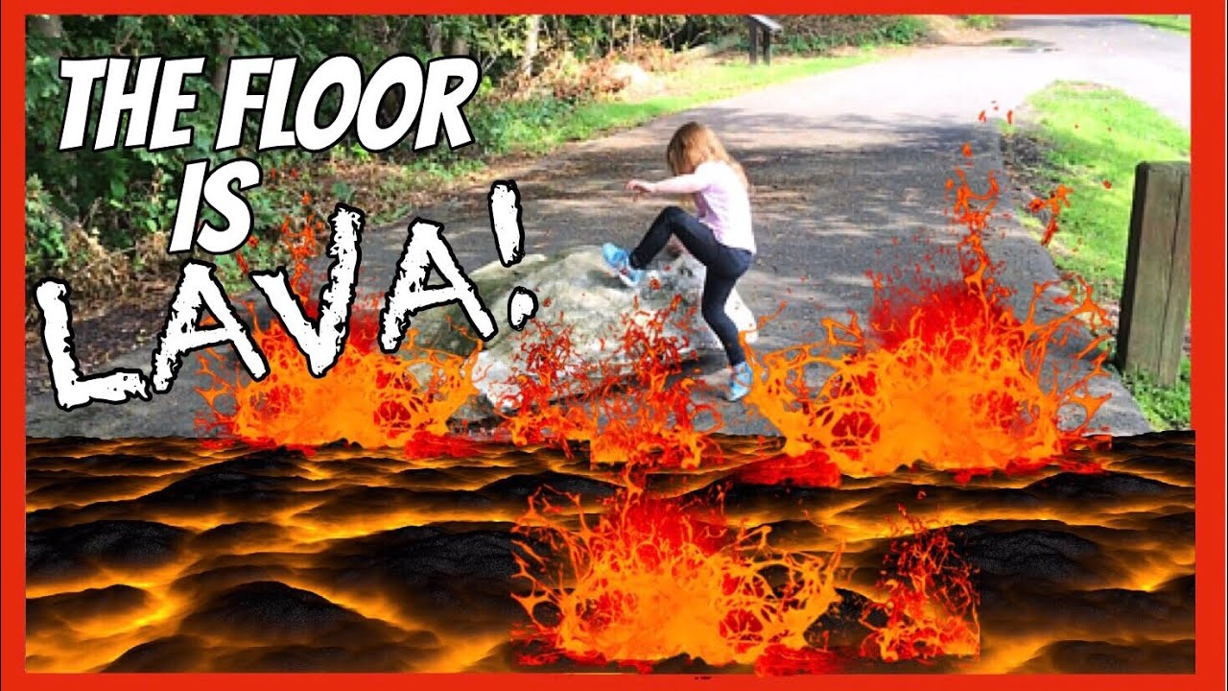
Students compete to be the last person standing from their class that hasn’t fallen into the lava or been tagged by the lava monster
Dance Battle
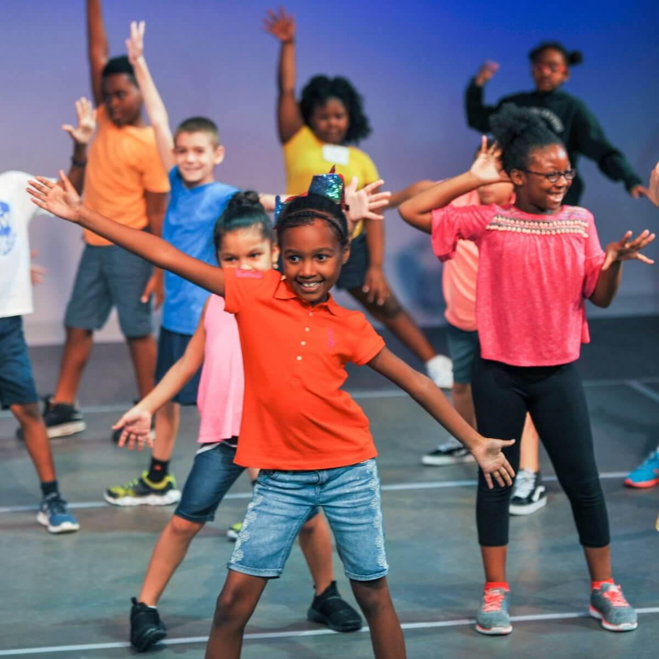
Classes will be recorded and judged performing their class dance.

- Music must be sent to coach almond ahead of time

Rockin’ Roller Racer Relay
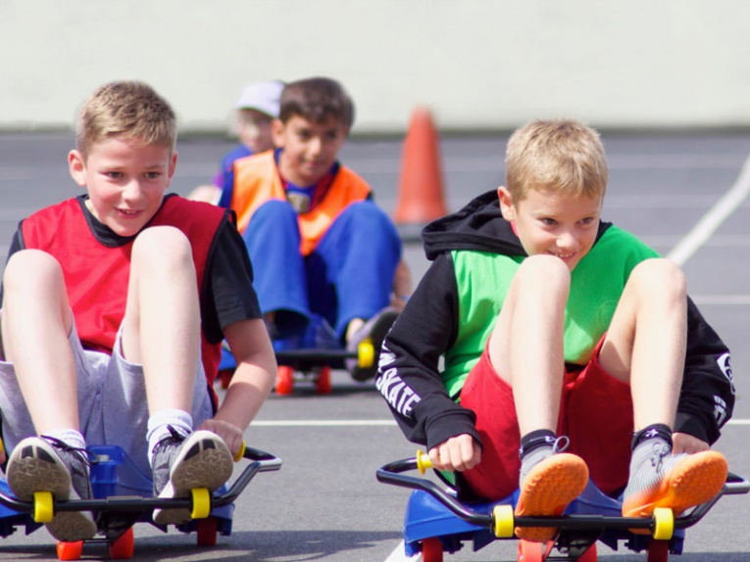
Students compete to be the first class finished to win the point.

- Classes must be evened out prior to beginning the race (determine if students must go more than once).
Field Goal Challenge
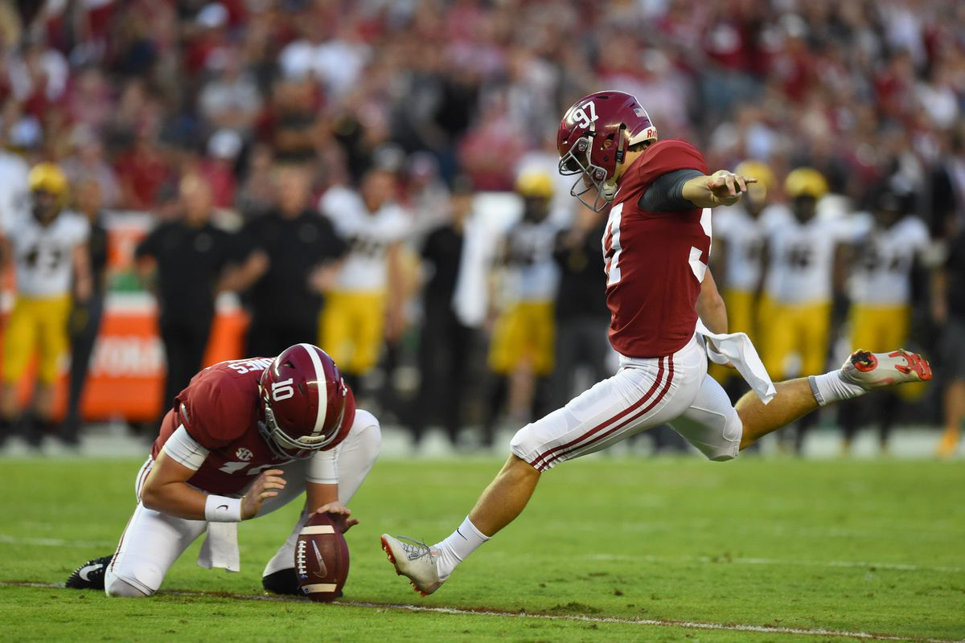
Students kick at their field goal. The class that scores the most goals wins the point.

Hoppin’ Hurdles Relay
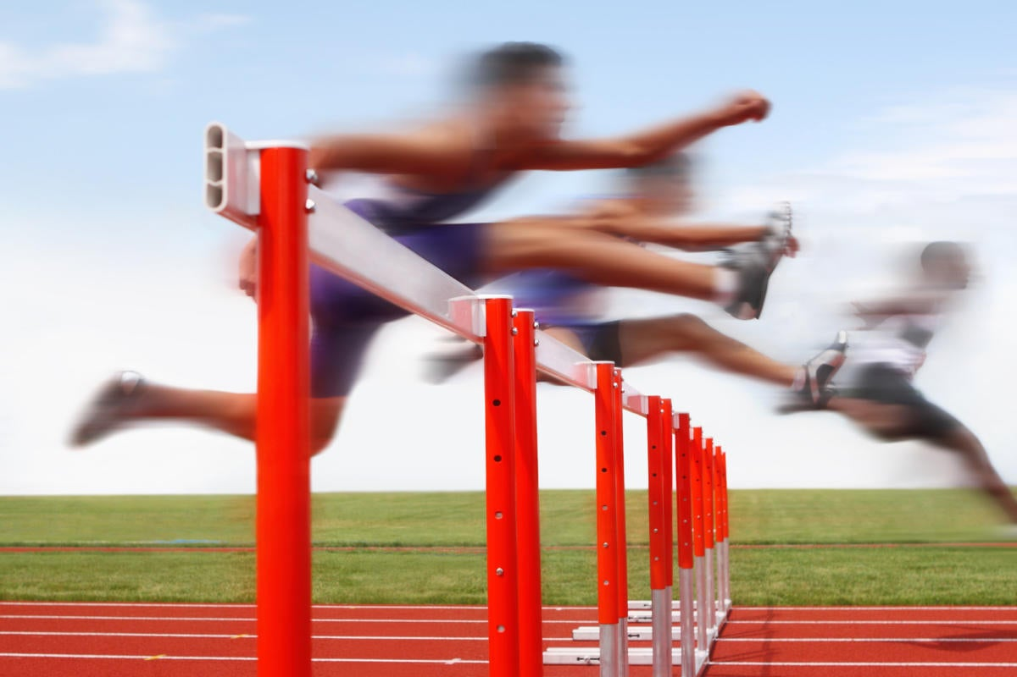
Students compete to be the first team finished in the race.

- Classes must be evened put prior to beginning the race.

Splash Waterfalls
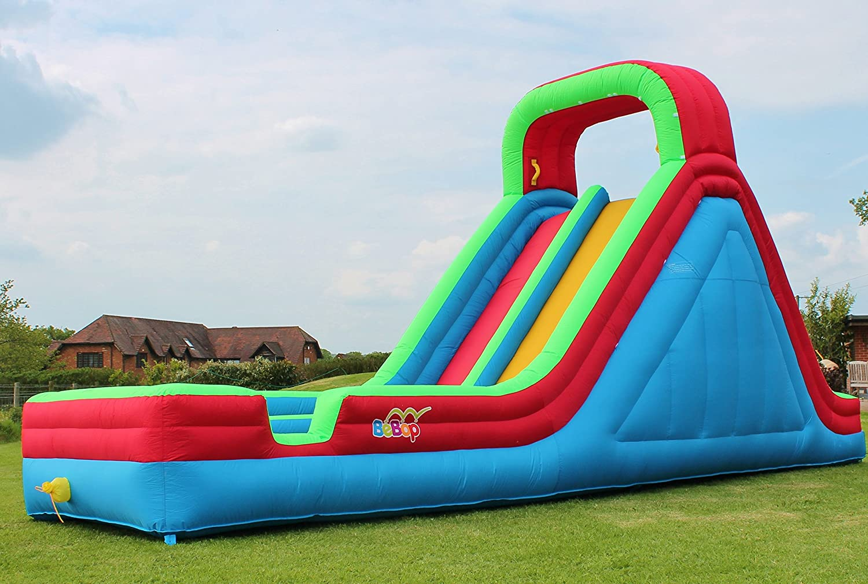
Students take turns sliding down the slide.

* Students must place their shoes on the tarp.
*

Popsicle Break
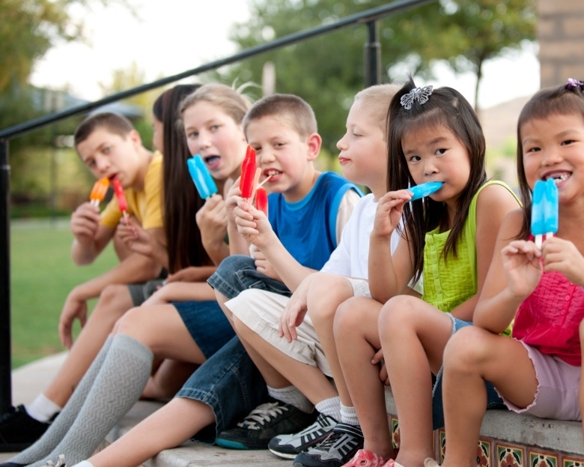
Students take a break with a popsicle.

- This is a good time to take a bathroom break.
Parrot Bay:
Paddle Cup Relay
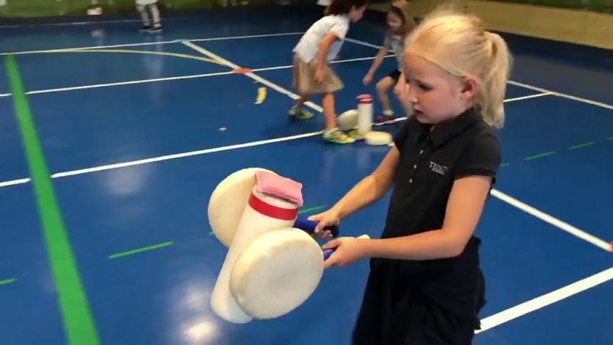
Students balance a cup of water on a paddle in this relay race. The class with the most water in their bucket wins the point.

Catching Some Waves: Water Balloon Toss
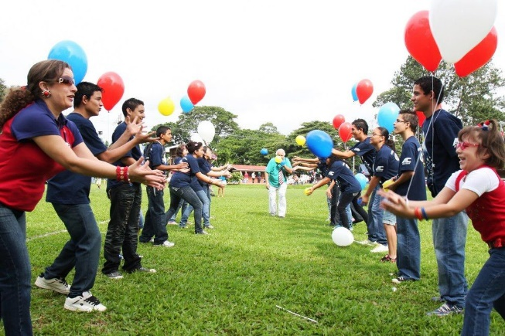
Students toss water balloons back and forth on command. The class that has the last pair of students with a water balloon wins the point.

Water You Doing?
Leaky Cups Relay
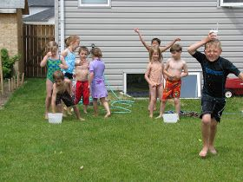
Students hold a cup with a hole in the bottom over their head and run to their bucket to fill it up. The class with the fullest bucket wins the point.

Surfin’ Slide
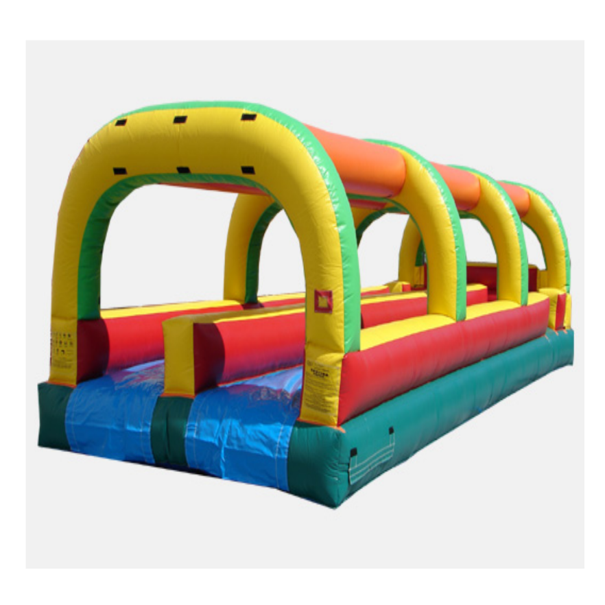
Students take turns sliding through the inflatable slip and slide.

- Students must place their shoes on the tarp prior to using the slip and slide.
Sponged Relay
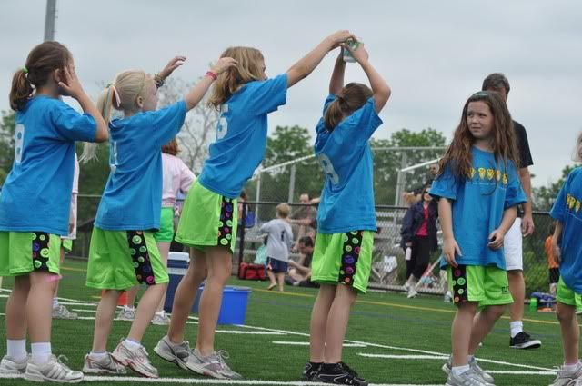
Students compete in a relay to see which class has the most water in their bucket after each student passes the sponge over their head.

Making a splash:
Tug-of-War
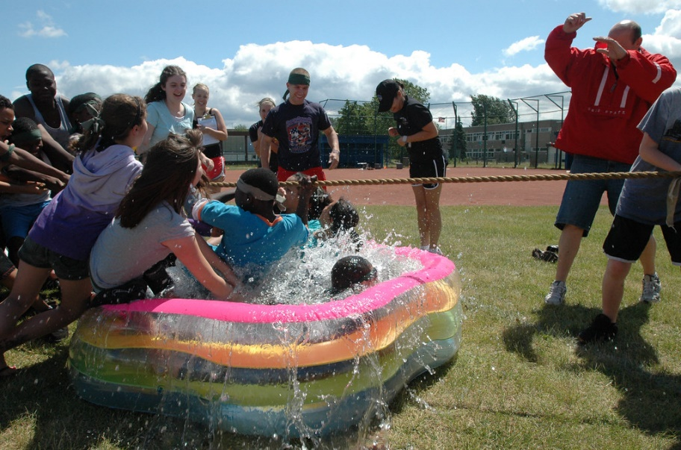
Students compete in different class versus class tug-of-war competitions for points.

Crystal Cliff:
Slip and Slide Target Game
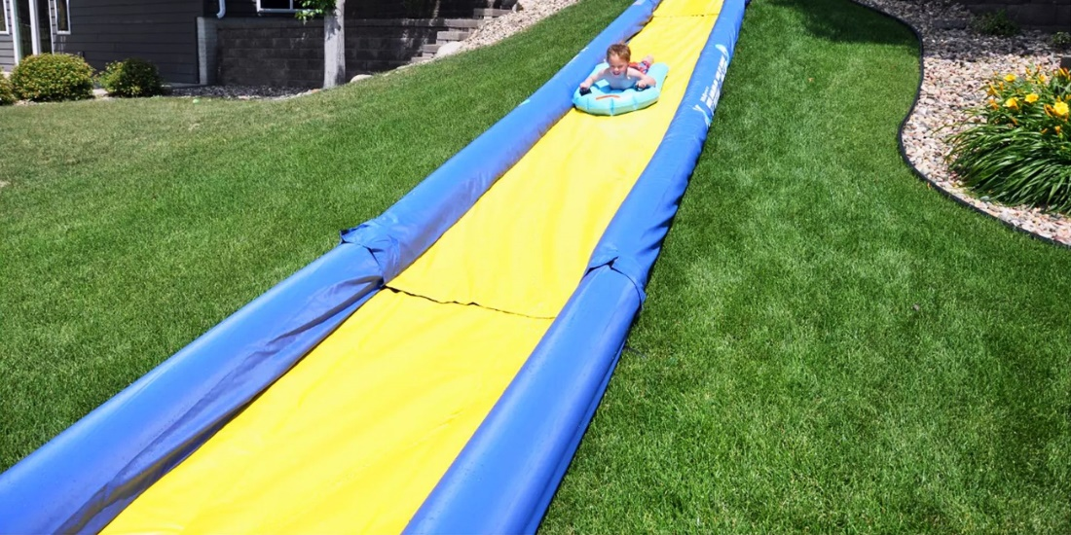
Students slide down the slip and slide and throw 2 frisbees at the disc golf target. The class that hits the target the most wins the point.

