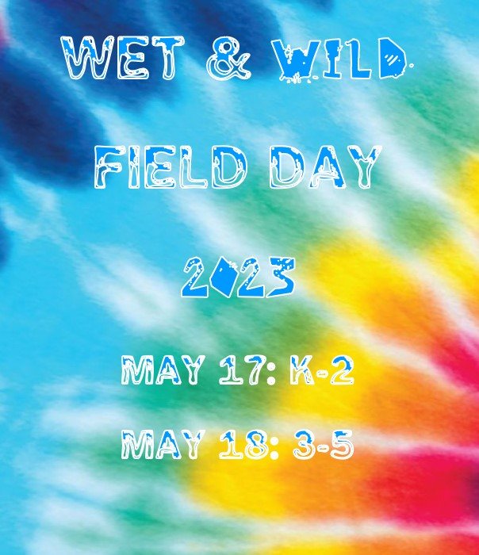

Field Day 2023
Field Day is an incredible time of the year for the parents, staff, and the students. It is filled with games and fun for everyone to enjoy. Memories will be remembered on our cameras, phones, and above all, our hearts. To make sure this is a great memory in your life, here is a guide that will help make sure your Powder Springs Elementary School Field Day is a memory you will enjoy!
Make sure to share your memorable moments on Instagram, Facebook, and Twitter!
WARNING: The contents of this guide are intended for individuals planning on having an exciting, fun-filled day. Individuals planning to use this guide other than its intended purposes will result in immediate consequences.
WATER HAZARD: This is a warning to say that there is a high possibility that you could get wet. However, this is also completely avoidable if desired. I would suggest bringing a towel and spare change of clothes and/or wearing a bathing suit underneath clothes just in case.
FIRST AID: First aid station will be located outside for treatment on the ouches and boo boos that could occur during the special day.
K, 1st, 2nd GRADES: FIELD DAY IS WEDNESDAY, MAY 17
3rd, 4th, 5th GRADES: FIELD DAY IS THURSDAY, MAY 18

Field Day Stations and Locations
1 Adrenaline Challenge
2 Break: Hydration Station
3 Pose & Print
4 Elimination: Roller Cage Ball
5 Lava Monster: Floor is Lava
6 Dance Battle
7 Rockin’ Roller Racer Relay
8 Field Goal Challenge
9 Hoppin’ Hurdles Relay
10 Splash Waterfall Water Slide
11 Break: Popsicles
12 Parrot Bay: Paddle Cup Relay
13 Catching some waves: Water Balloon Toss
14 Water you doing?: Leaky Cups Relay
15 Surfin Slide:Inflatable Slip and Slide
16 Sponged Relay
17 Making a splash: Tug of War
18 Crystal Cliff: Slip and Slide Target Challenge

K-2 Field 3-5 Field Blacktop Gym

The following items and criteria listed below are not required to participate in Powder Springs Elementary Field Day 2023. However, the more items checked will increase the likelihood of happiness on our beloved day. See checklist below.
Field Day Checklist for Students:
____ Powder Springs Field Day T-Shirt
____ Sunscreen
____ Water Bottle
____ Hat
____ Sunglasses
____ Change of Clothes
____ Towel
____ Smiling Face
____ Your Favorite hair style

Teacher Checklist:

____ Read Field Day Packet in its entirety. If you have any questions, please ask.
____ Reread the packet. Please know what to expect before and during field day.
____ Find volunteer to help monitor class
____ Plan to make lunch special (figure out location for sack lunches, get families involved, etc.)
____ Plan for a class snack/ drink break (request donations)
____ Tie Dye field day shirts
____ Create a class dance routine for the dance battle
____ Send home information about Kona Ice/Aloha Ice for students (but do NOT touch student money)

